Strong et al 2011

* In situ SSTs from buoys (drifting and moored) are used operationally to maintain satellite-derived SST accuracy by removing biases and compiling statistics with time (McClain et al. 1985, Strong 1991, Strong et al. 2000).
* Many of NOAA’s other operational SST products are produced by blending day and night observations; however, in the tropics, nighttime SST products have been demonstrated to compare more favorably with in situ buoy SSTs at 1 m depths (Montgomery and Strong 1995).

McClanahan et al 2007

* No in situ comparison, only used satellite, and blended satellite/shipboard temp products
* 50km x 50 km NOAA and 1x1 degree JCOMM
* Validation was primarily coral bleaching against these two products

Gleeson and Strong 1995

* Nighttime MCSST weekly averages were compared with moored-buoy temperatures for sea-truthing the satellite. Average errors from 11 individual buoy comparisons throughout the tropics were found to be approximately 0.5bC.
* First DHW derivation
* No reliable in-situ SST time series exist for many coral reef locations. Therefore, the primary data source for this study was National Oceanic and Atmospheric Administration (NOAA) Multi-Channel Sea Surface Temperature (MCSST) data collected from 1982 through 1992.
* Satellite-derived time series were produced at 11 NOAA buoy sites and then compared with the buoy records.
* 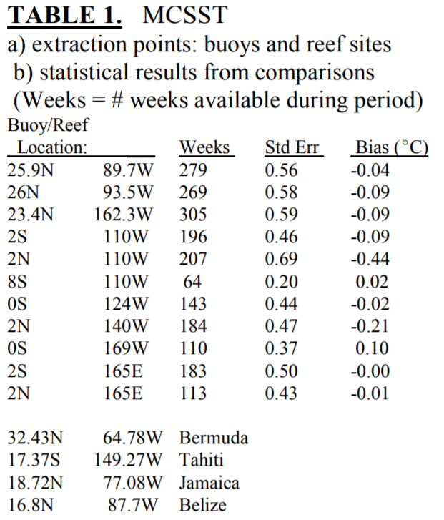
* Lacks information, does not explicitly say what statistical comparisons were conducted

Wellington et al 2001 - Sea surface temperature variation in the Galápagos Archipelago: a comparison between AVHRR nighttime satellite data and in situ instrumentation (1982–1998)

* ACTUALLY DOES IN SITU/SATELLITE COMPARISON
* Comparisons were made at monthly (1982–1998) and weekly (1997–1998) resolution.
* Results of within-site comparisons indicated that the differences in monthly SSTs for the two methods, at four primary sites, ranged from a mean difference of −0.62°C to a high of +1.39°C. Weekly comparisons made during the very strong 1997–1998 ENSO event revealed smaller differences between methodologies (−0.33 to + 0.99) due to the widespread warming resulting from ENSO conditions.
* While a statistical evaluation of the data revealed few overall differences between sites and methods, two sites, Champion and Urvina Bay, showed consistent differences between the two methodologies.
* We evaluated the differences between sites and methods (instrumental and satellite) for the two SST time series (1993–1998 monthly resolution and 1997–1998 weekly resolution) and seasonal differences between and within sites using the general linear model package in SYSTAT® 9.0. When main effects or their interactions were found to be significant we employed the Tukey (honesty significance difference test — HSD) Multiple Comparisons procedure to evaluate pair-wise differences between individual sites and/or methods. This test is considered robust for small numbers of comparisons (Zar, 1984).
* 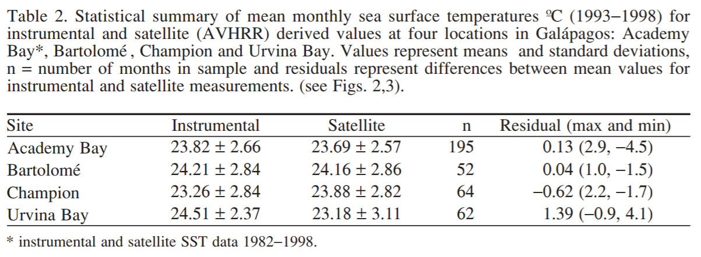
* 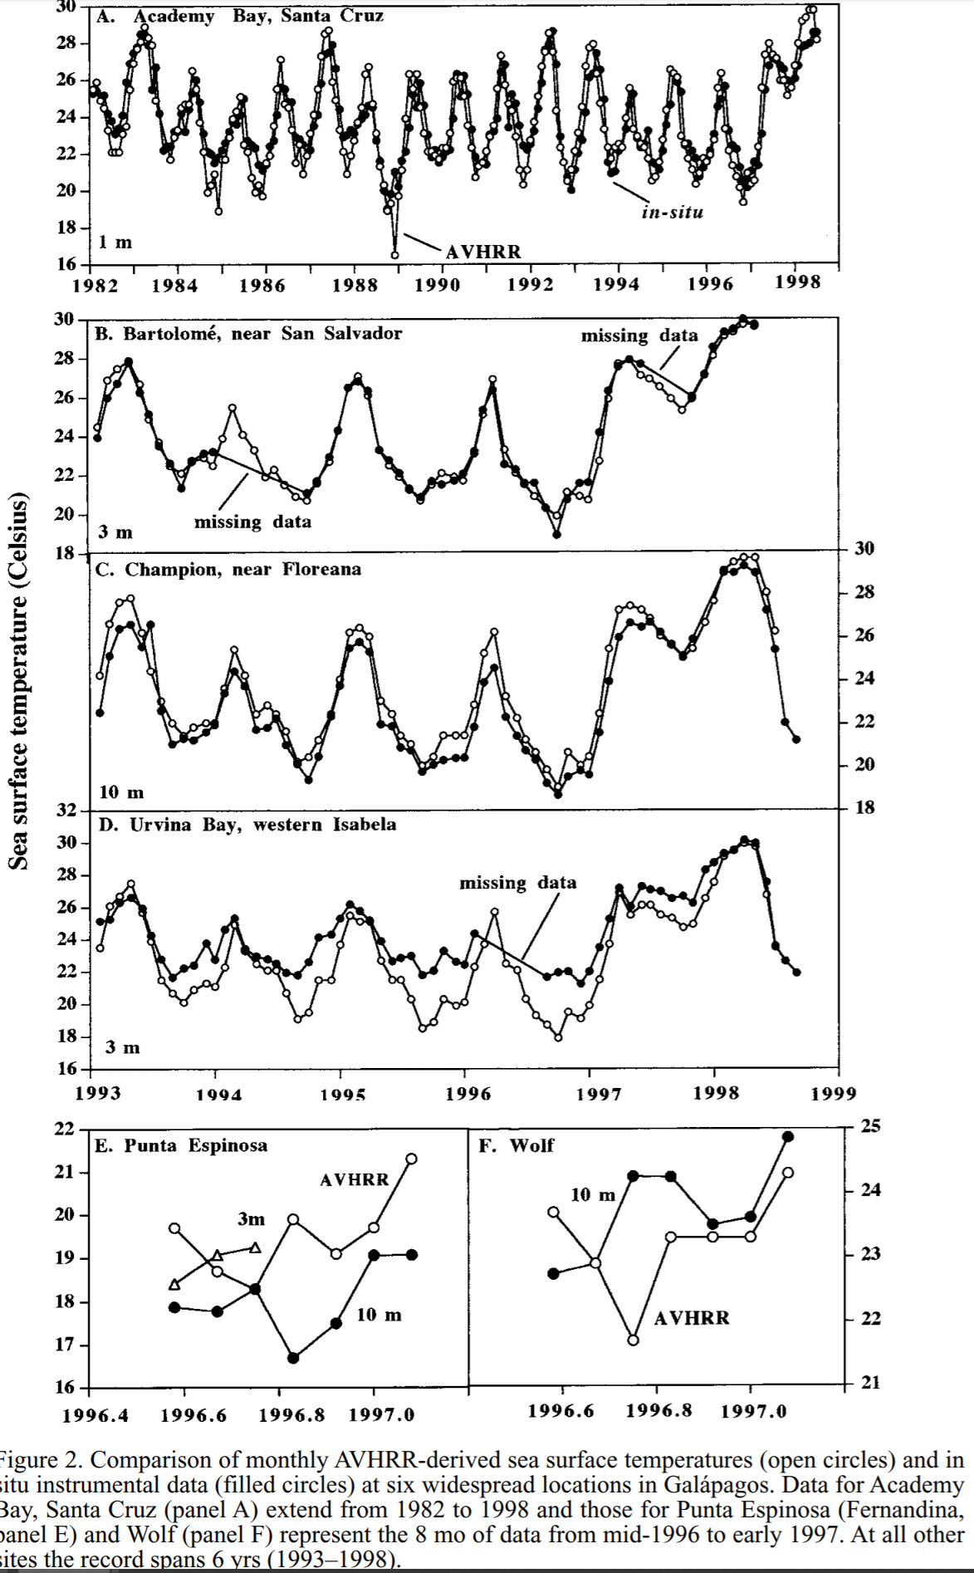
* 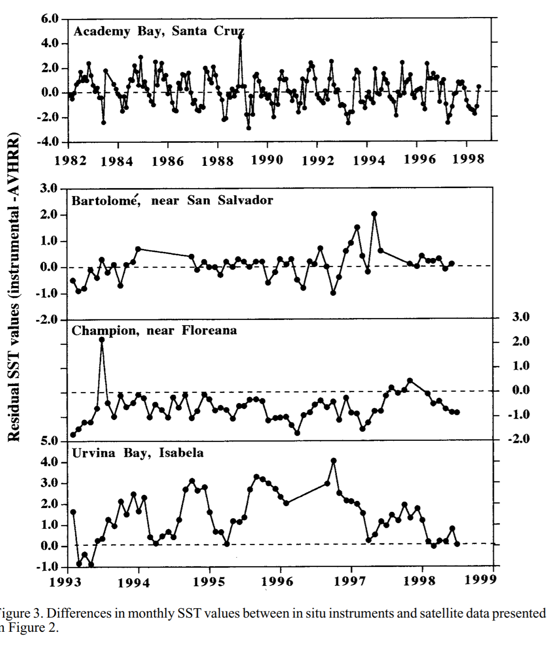

Strong et al 2002

* The comparison between the satellite SSTs and several in situ temperature observations in the region shows that the NOAA satellite HotSpot technique was remarkably informative in showing the onset, development, and dissipation of the warming event
* 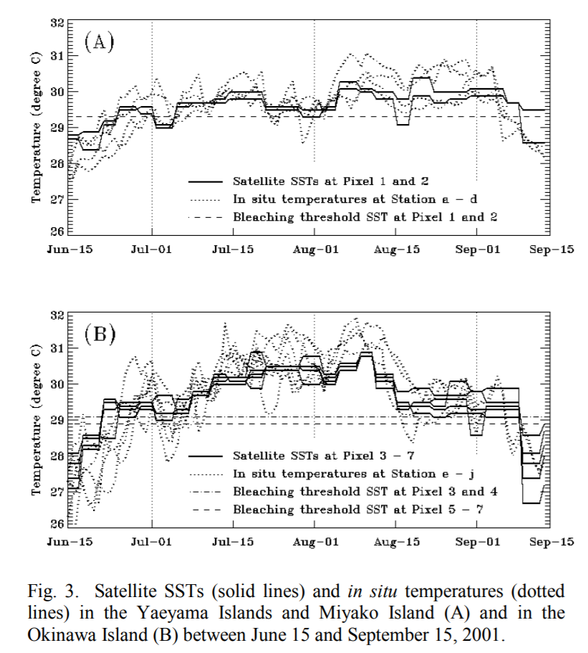

Aronson et al 2002

* Mostly comparing to biological change, but did compare satellite with in situ
* 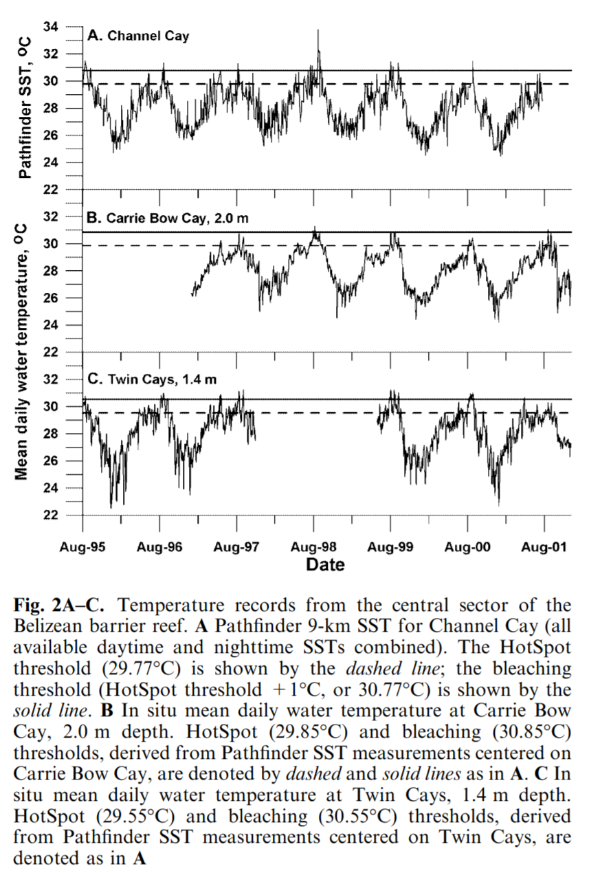
* 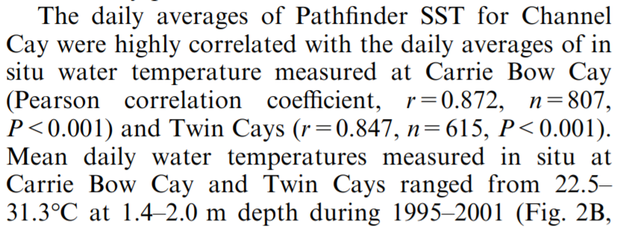

Stobart et al 2016- Comparison of in situ and satellite sea surface-temperature data from South Australia and Tasmania: how reliable are satellite data as a proxy for coastal temperatures in temperate southern Australia?

* Mean annual daily temperature differences between SST and IST (DTD) were generally small, varying spatially and seasonally (range 0–1°C).
* Generally, small annual mean DTDs justify using SST for broad-scale ecological and climate-change studies, although considerable DTDs at some sites suggest that using SST at smaller spatial and temporal scales is unlikely to be appropriate.
* In addition, SST data lack information on daily temperature fluctuation that may be biologically relevant.

Casey 2002 – Response to wellington 2001

* A recent study by Wellington et al. (2001) excluded daytime and selected only nighttime AVHRR sea surface temperature (SST) data for comparison with in situ observations, citing two studies to support this decision. One of these studies is incorrectly referenced since it does not discuss day-night satellite data issues, and the other supports the use of nighttime AVHRR data based on biases with a single buoy recording SST in a different ocean basin. This report discusses the diffculty in selecting only daytime or nighttime AVHRR data based on dissimilar studies owing to highly variable satellite SST biases and differences in satellite processing algorithms. Additionally, it presents a simple analysis based on co-located satellite and in situ data which highlights two important processes affecting the day-night satellite SST differences: diurnal warming and the skin effect.

Hendee et al 2002 - NEAR REAL-TIME VALIDATION OF SATELLITE SEA SURFACE TEMPERATURE PRODUCTS AT RAINBOW GARDENS REEF, LEE STOCKING ISLAND, BAHAMAS

* Near Rainbow Gardens Reef, where the first CREWS station was installed, additional in situ data loggers were deployed to compare with CREWS and satellite SST data for both the relatively shallow Great Bahama Bank and much deeper Exuma Sound. During summer, 2001, CREWS successfully transmitted daily email satellite SST and in situ temperature comparisons, which showed good agreement.
* 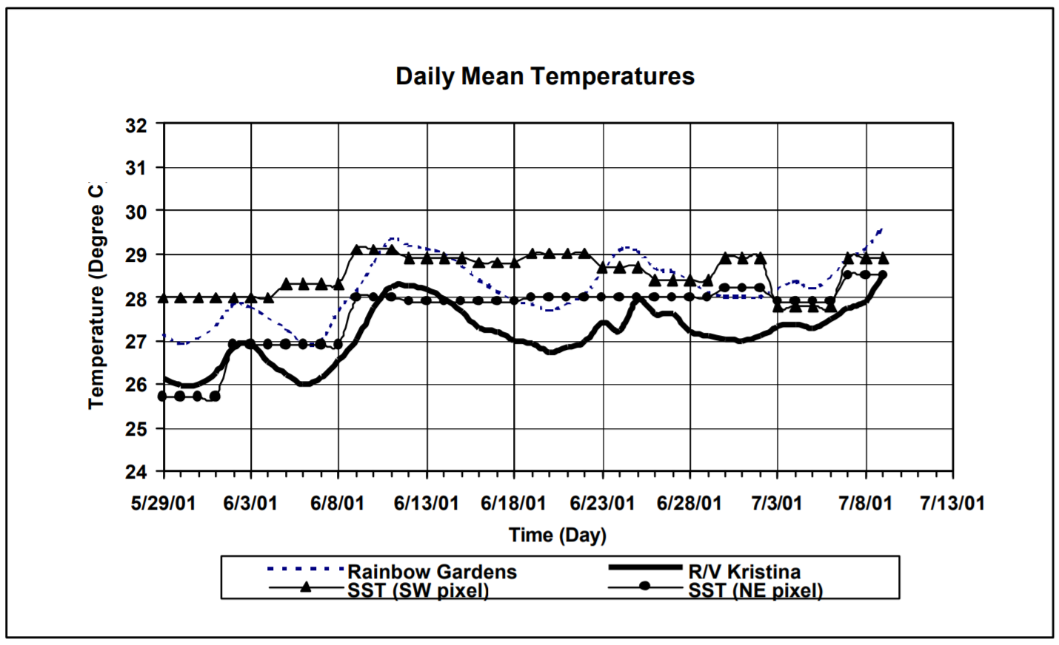

Stobart et al 2008 - Comparison of in situ temperature data from the southern Seychelles with SST data: can satellite data alone be used to predict coral bleaching events?

* We compare satellite sea surface temperature data from four locations with in situ temperature measurements at 6m, 10m and 20m depth. Typically in situ temperature measurements do not differ from satellite measurements by more than 1ºC, though on occasions the difference can be as much as 4ºC. SST data is most similar to in situ data during the winter, and least similar during the summer. This is most likely due to water column stratification during the summer which is typified by calm weather with weak winds, while during the winter strong south easterly winds reduce stratification.
* 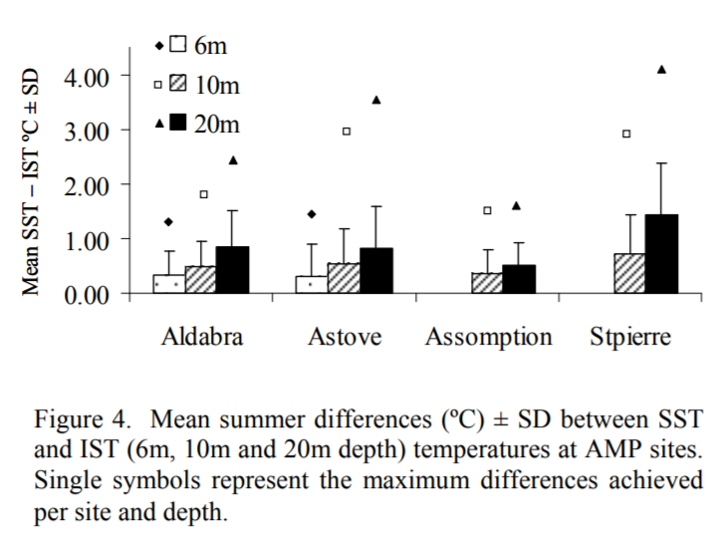
* 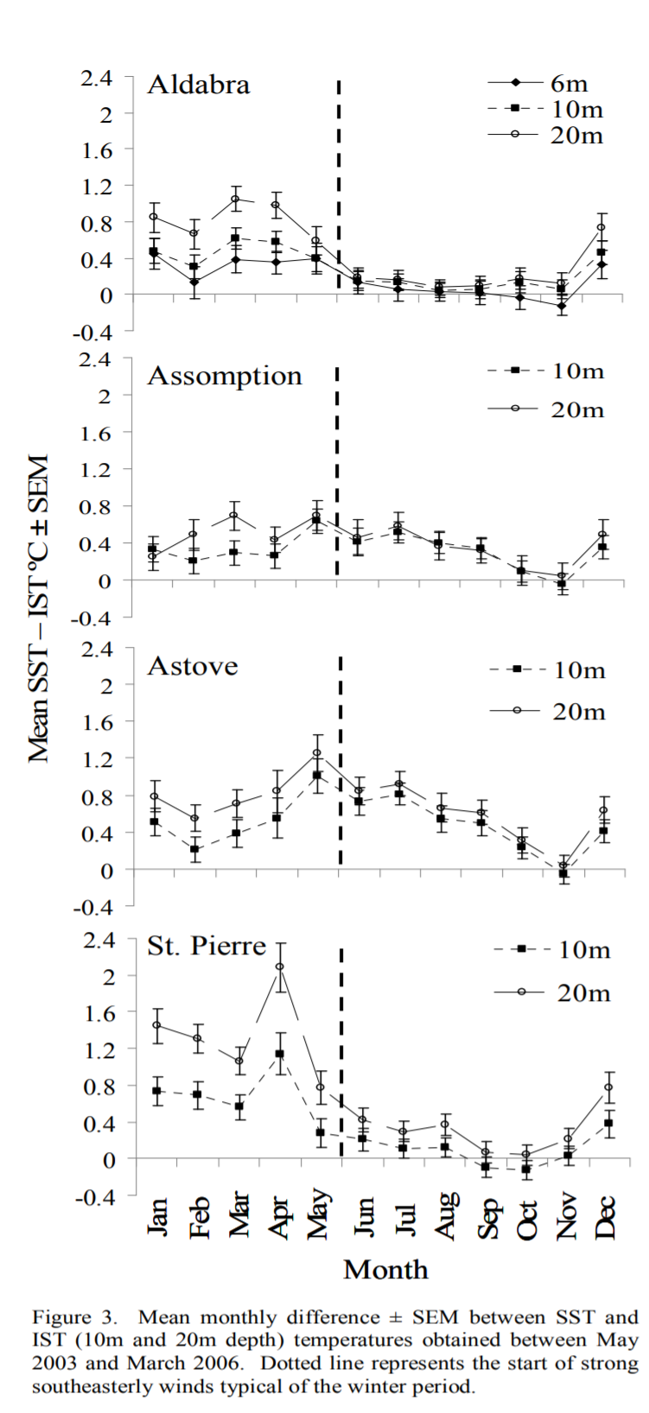

Castillo and Lima 2015 - Comparison of in situ and satellite‐derived (MODIS‐Aqua/Terra) methods for assessing temperatures on coral reefs – IMPORTANT – need to read whole paper

* Thermal stress has been regarded as one of the most important parameters monitored on reefs to assess coral health, and therefore, it is important to have accurate temperature data for reef environments. Whereas most studies of thermal stress on reefs have relied on sea surface temperature (SST) data, recent findings have suggested that subsurface temperatures may differ considerably from those at the surface. We compared concomitant in situ and satellite‐derived SST measurements on two different coral reefs off southern Belize. Seawater temperatures adjacent to corals at 3 to 5 m depth were measured every 10 to 30 min, from June 2002 to December 2007. An accompanying data set of seawater temperatures was collected every 10 min at 1, 3, 6, 9 and 15 m depth, from October 2006 to December 2007. Concurrent nighttime and daytime SST measurements from MODIS Aqua and Terra platforms with a spatial resolution of 4 km were obtained for comparative purposes. Results indicate a negative (cool) bias for remotely sensed SSTs when compared with in situ measurements for both satellites across these two locations. Compared with daytime values, nighttime satellite‐derived SST measurements yielded larger negative biases and were less correlated with in situ measurements. Understanding these biases will not only provide a better evaluation of the thermal regime on individual reefs, but will also create opportunities for more precise temperature comparisons among coral reef environments. We stress the importance of “sea‐truthing” and complementing satellite‐derived SST readings with in situ data when measuring temperatures on coral reefs.

Bernardello et al 2016 - A comparison of remote-sensing SST and in situ seawater temperature in near-shore habitats in the western Mediterranean Sea

* We compared remote-sensing SST from the MODIS sensor (aboard the Aqua satellite) to near-shore seawater temperature (ST) recorded in situ with data loggers at 5 locations in the western Mediterranean Sea. In situ ST data were collected at 5 m depth over a ~6 yr period and at depths below 5 m at 3 of the locations.
* MODIS reproduced seasonal variability with high correlations (r > 0.98) and biases (0.59 ± 0.03°C) only slightly higher than the accuracy of the loggers (0.50°C).
* When evaluated for intra-seasonal temperature variability, MODIS showed limited biases (up to 0.79°C) with a tendency to overestimate the variability (between 4 and 64%) in both cold and warm seasons. Finally, MODIS over-/underestimated only the most extreme unseasonably cold/warm events (by 1.51 and −0.79°C, respectively).
* 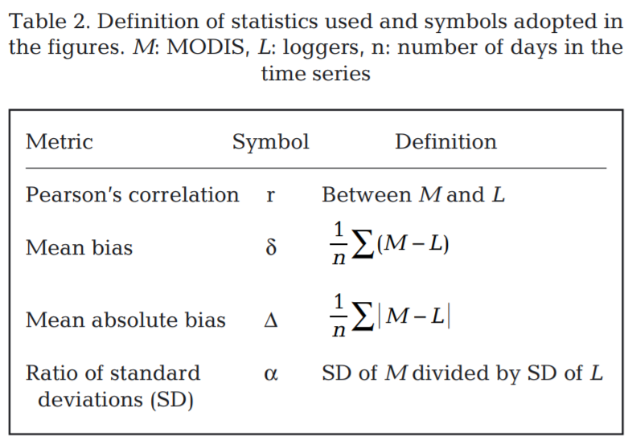
* 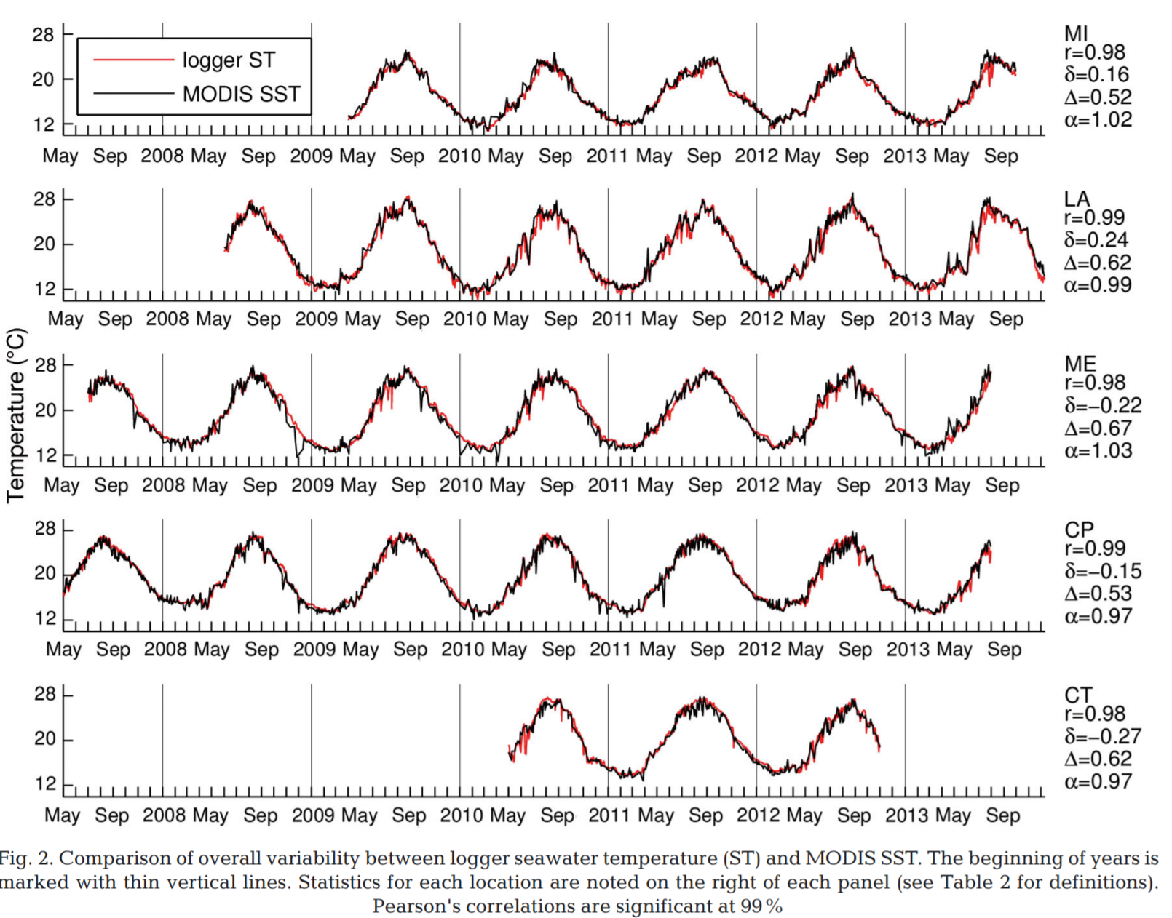
* 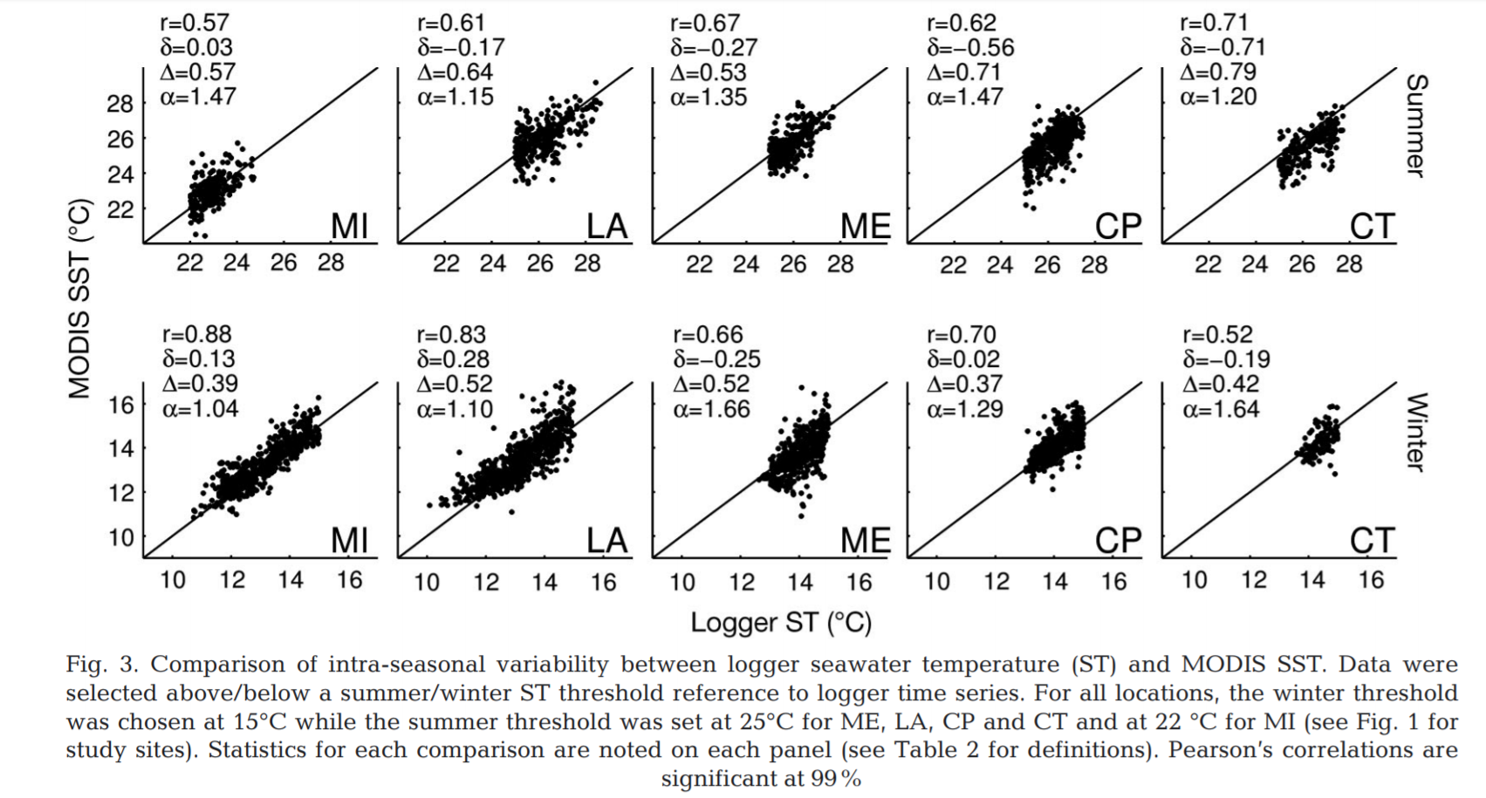
* 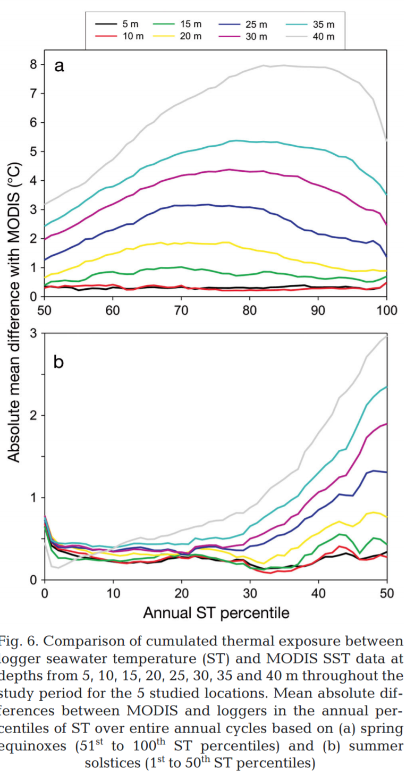 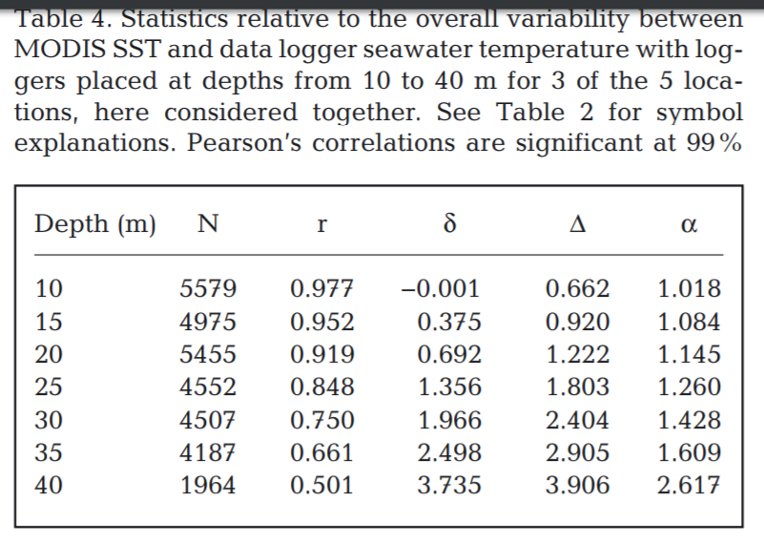

Thackur et al 2016 - Suitability of remotely-sensed sea surface temperature for aquaculture research: Comparison with in situ records from salmon farms in British Columbia (BC), Canada

* Tested correlation between in situ and satellite temp
* 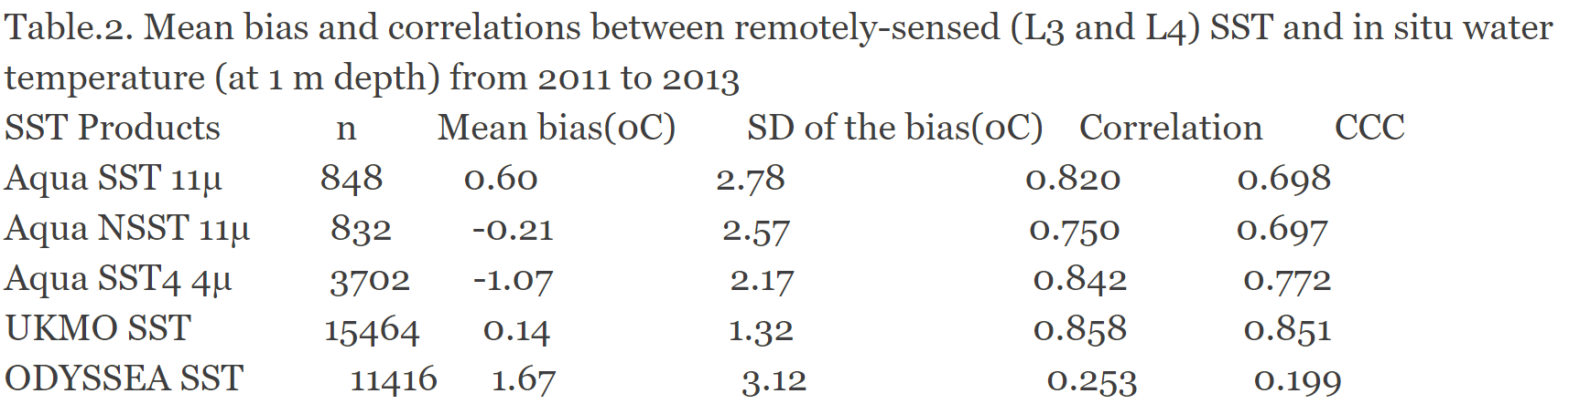
* 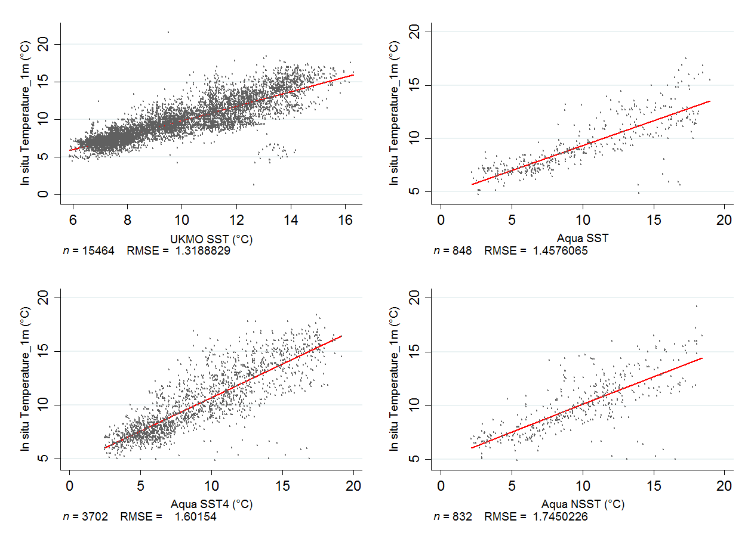

Weeks et al 2008 - Improved predictions of coral bleaching using seasonal baselines and higher spatial resolution

* Missed bleaching on Heron Island in 2006 because it was based on 50-km, annual thresholds
* Here it is shown that such problems can be ameliorated if the thermal threshold is adjusted for seasonal variation and a 4-km spatial resolution is used. We develop a seasonally and spatially improved thermal threshold for coral bleaching on the basis of a weekly climatology of sea surface temperatures extending from austral spring to late summer, and apply the method to two case-study sites.
* No in situ comparison, but I like the figure below for dataset comparison
* 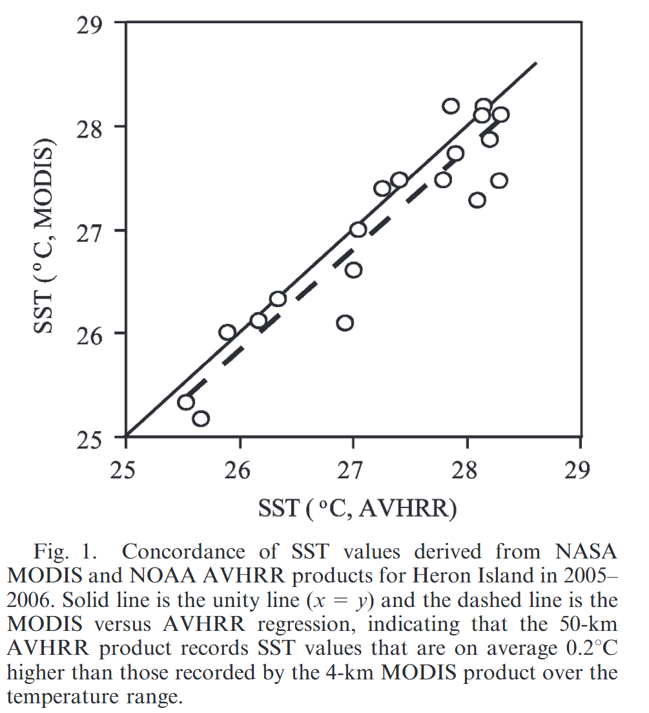

Mumby et al 2004 - Remote sensing of coral reefs and their physical environment

* Review of remote sensing tools and capacity
* Talks about NOAA products, but no new comparisons included

Sheppard 2009 - Large temperature plunges recorded by data loggers at different depths on an Indian Ocean atoll: comparison with satellite data and relevance to coral refuges

* Seawater temperature was recorded at two hourly intervals for two years (March 2006-March 2008) by six data loggers in Diego Garcia atoll, central Indian Ocean. Loggers were substrate mounted, in two transects of 5, 15 and 25 m depth on a seaward reef and in a lagoonal pass.
* Temperature traces are compared with HadISST1 and AVHRR satellite-derived temperature data which do not capture the deeper water temperature plunges. Reasons for the regular temperature plunges appear to include both tidal cycles and unidentified, internal waves
* 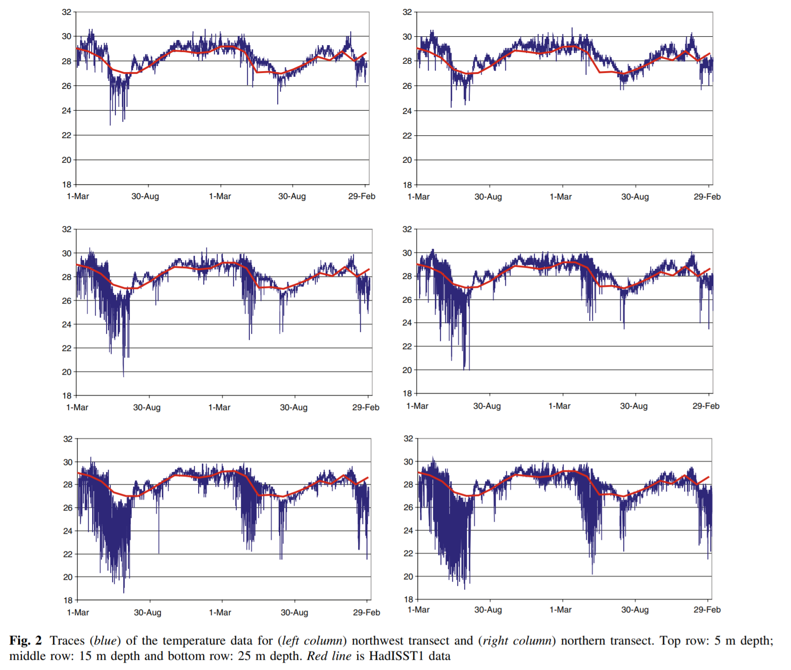
* No refuge existed in 1998, probably due to a deeper and more stable warm surface layer due to abnormally low winds

Sheppard and Rayner 2002 - Utility of the Hadley Centre sea ice and sea surface temperature data set (HadISST1) in two widely contrasting coral reef areas

* Probably don’t need to include – only looking at HADISST at two different locations (HADISST is created using blended satellite and in situ observations)

Hoeke et al 2009 - Coral reef ecosystem integrated observing system: In-situ oceanographic observations at the US Pacific islands and atolls

* 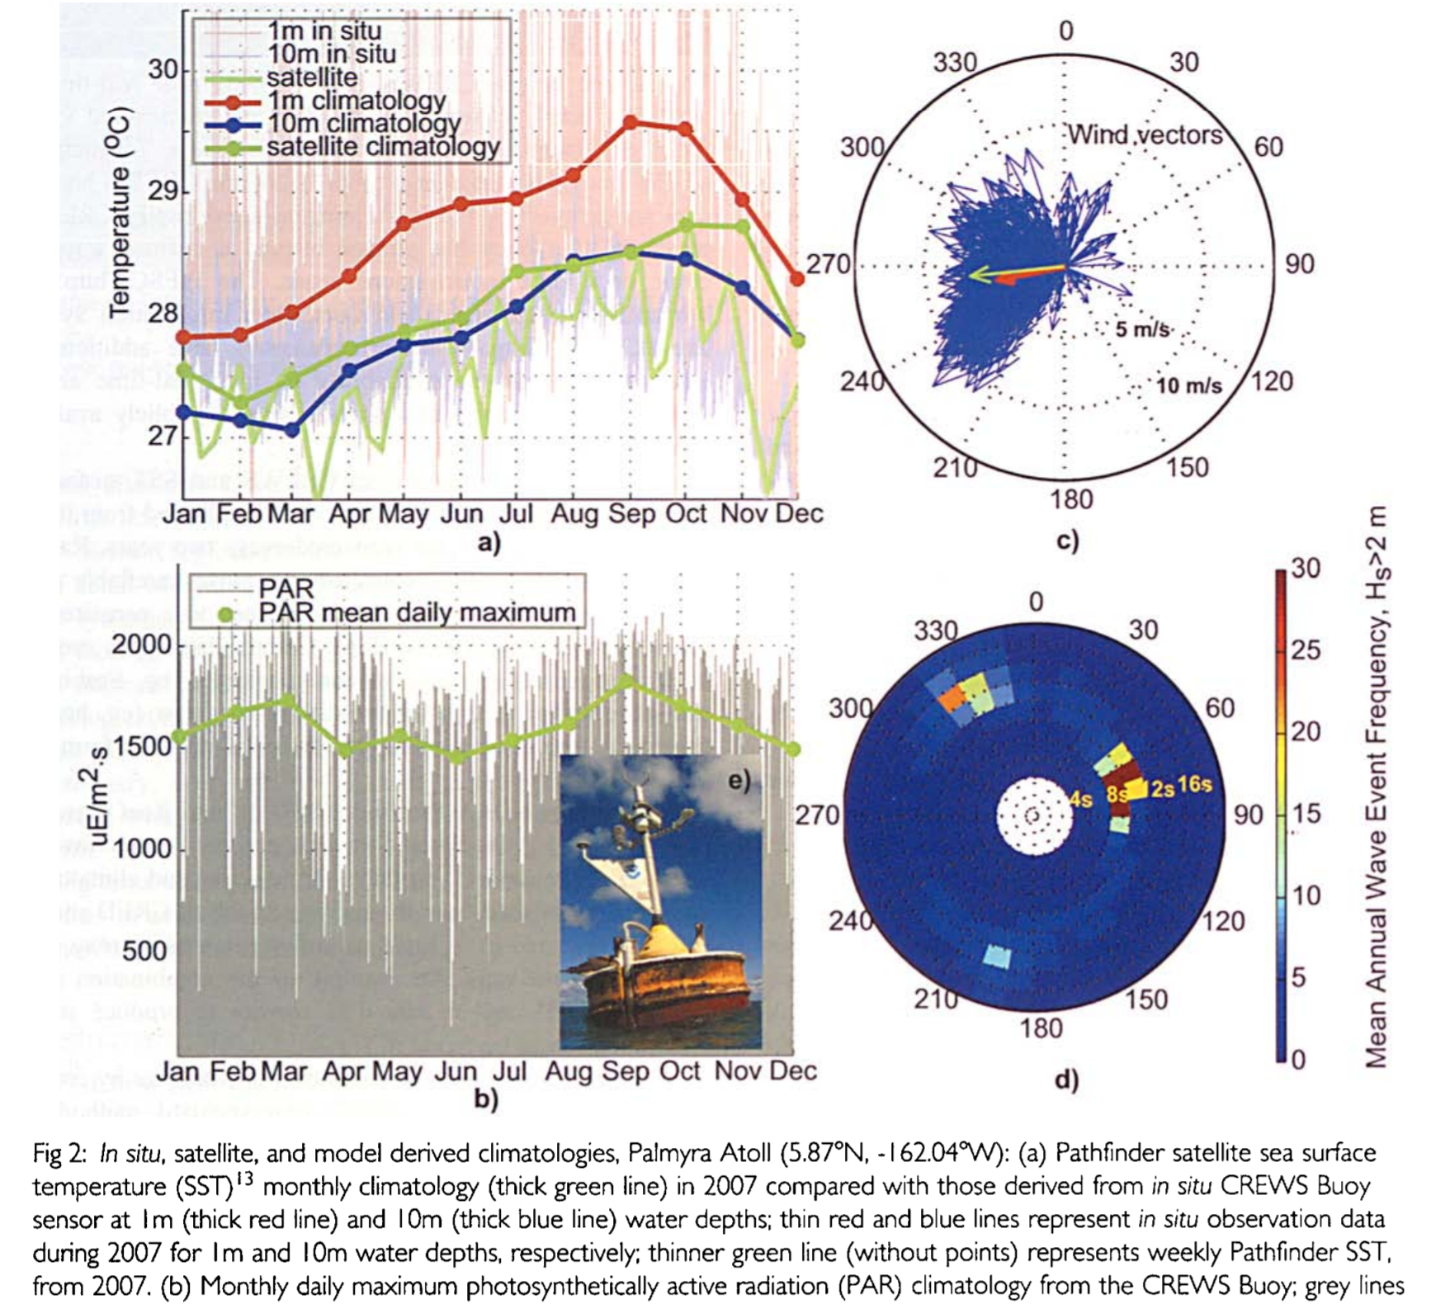
* 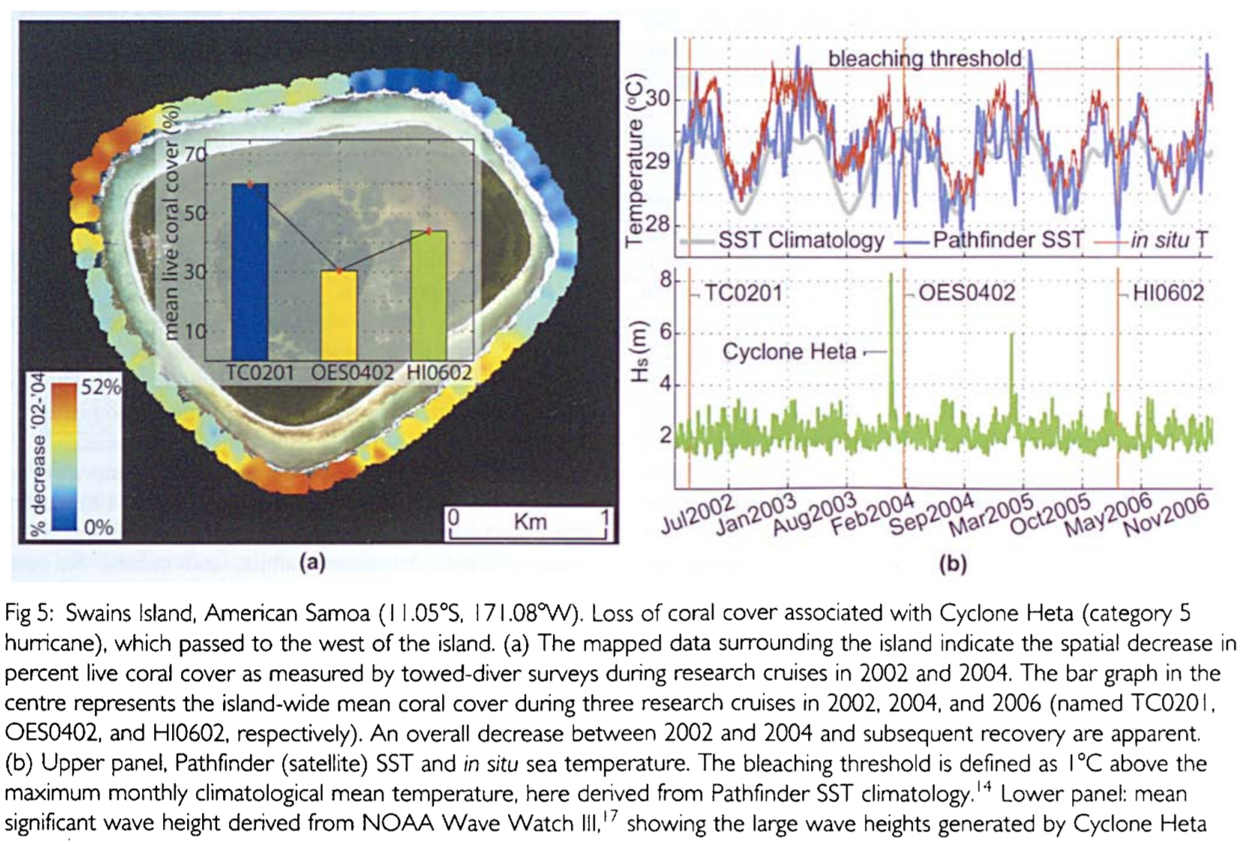
* A few examples of in situ vs pathfinder, but no statistical comparisons between them as far as I can tell

Strong et al 2000 - Sea surface temperature signals from satellites—An update

Maynard et al 2008 - ReefTemp: An interactive monitoring system for coral bleaching using high‐resolution SST and improved stress predictors

* Here we discuss the development and testing of ReefTemp, a new operational remote sensing application for the Great Barrier Reef that assesses bleaching risk daily using: high‐resolution (2 km) SST, regionally validated thermal stress indices, and color‐graded legends directly related to past observations of bleaching severity.
* No in situ comparison

Gorospe and Karl 2011 - Small-scale spatial analysis of in situ sea temperature throughout a single coral patch reef

* Thus, to investigate fine spatial scale sea temperature variation, temperature loggers were deployed on a 4 m grid on a patch reef in Kāne'ohe Bay, Oahu, Hawai‘i to monitor in situ, benthic temperature every 50 minutes at 85 locations for two years.
* 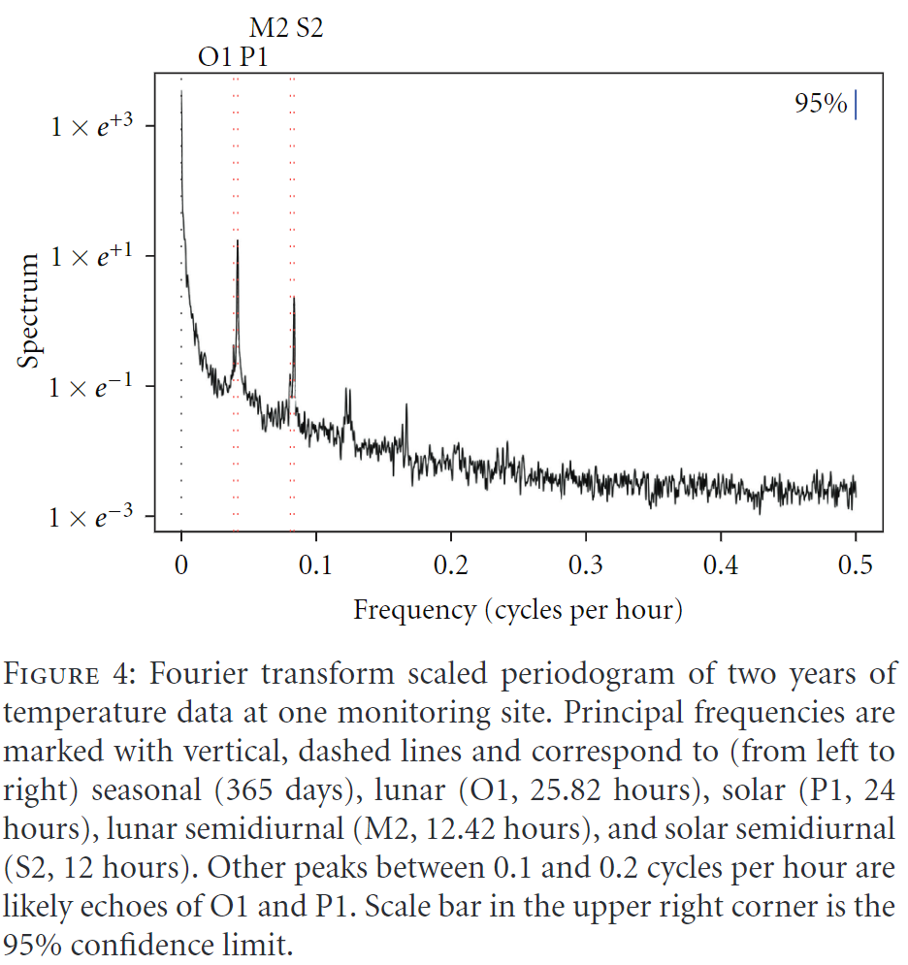
* In both cases, in situ temperature data at the scale of the individual colony can provide the environmental context for interpreting results and gaining a more comprehensive understanding of the spatial heterogeneity seen in bleaching patterns and thresholds of thermal stress for coral.

Liu et al 2012 - NOAA Coral Reef Watch's decision support system for coral reef management

Baldock et al 2014 - Accurately estimating local water temperature from remotely sensed satellite sea surface temperature: A near real-time monitoring tool for marine protected areas

Liu et al 2014- Reef-scale thermal stress monitoring of coral ecosystems: new 5-km global products from NOAA Coral Reef Watch

Yamano et al. 2014 - Detection limits of coral reef bleaching by satellite remote sensing: simulation and data analysis

Mohammed et al 2015 - Performance evaluation of CRW reef-scale and broad-scale SST-based coral monitoring products in fringing reef systems of Tobago

Purkis et al 2015 - Spatial and temporal dynamics of Arabian Gulf coral assemblages quantified from remote-sensing and in situ monitoring data

Smit et al 2013 - A Coastal Seawater Temperature Dataset for Biogeographical Studies: Large Biases between In Situ and Remotely-Sensed Data Sets around the Coast of South Africa

Eakin et al. 2018 – Book Chapter: Climate Variability and Change: Monitoring Data and Evidence for Increased Coral Bleaching Stress

Liu et al 2006 - Overview of NOAA coral reef watch program's near-real time satellite global coral bleaching monitoring activities

McClain, E.P., Pichel, W.G., and Walton, C.C., 1985. Comparative performance of AVHRR-based multi channel sea surface temperatures. Journal of Geophysical Research, 90, 11587.

Casey, K.S. and Cornillon, P.A., 1999. Comparison of satellite and in situ based sea surface temperature climatologies. Journal of Climate, 12, 1848–1863.

Strong, A.E., 1991. Sea surface temperature signals from space. In: W.A. Nierenberg„ ed. Encyclopedia of earth system science, Vol. 4. San Diego, CA: Academic Press, 69–80.

Strong, A.E., Kearns, E., and Gjovig, K.K., 2000. Sea surface temperature signals from satellites – an update. Geophysical Research Letters, 27 (11), 1667–1670. Strong, A.E., et al., 1997.

Montgomery, R.S. and Strong, A.E., 1994. Coral bleaching threatens oceans, life. EOS, Transactions, American Geophysical Union, 75, 145–147.

Liu G, Strong AE, Skirving W, Arzayus LF (2005) Overview of NOAA coral reef watch program’s near-real time satellite global coral bleaching monitoring activities. Proc 10th Int Coral Reef Symp 1:1783–1793

**NOAA CORAL TEMP**

The NOAA Coral Reef Watch (CRW) daily global 5km Sea Surface Temperature (SST) product shows the nighttime ocean temperature (at the surface) measured by CRW's CoralTemp Sea Surface Temperature Version 1.0 product. The SST scale ranges from -2 to 35 °C. This product is updated each afternoon at about 13:30 U.S. Eastern Time.

<https://coralreefwatch.noaa.gov/satellite/coraltemp.php>

NOAA Coral Reef Watch (CRW) produces a number of daily global 5km (approximately 0.05 degree) sea surface temperature (SST) based anomaly products. All of these rely on having an accurate climatology and a long enough time series of SST data that has consistent bias and errors and is either part of a near-real-time SST product or related to one.

Herein we present CoralTemp. Developed from two, related reanalysis (reprocessed) SST products and a near-real-time SST product, CoralTemp is one of the best and most internally consistent daily global 5km SST products, spanning January 1, 1985 to the present.

The source data for CoralTemp are from a combination of:

1) NOAA/National Environmental Satellite, Data, and Information Service's (NESDIS') operational near-real-time daily global 5km Geostationary-Polar-orbiting (Geo-Polar) Blended Night-only SST Analysis (the source data for which are shown in Figures 1 and 2);

2) NOAA/NESDIS' 2002-2016 reprocessed daily global 5km Geo-Polar Blended Night-only SST Analysis (the source data for which are shown in Figures 1 and 2); and the

3) 1985-2002 daily global 5km night-only SST reanalysis produced by the United Kingdom Met Office, on the Operational SST and Sea Ice Analysis (OSTIA) system (the source data for which are displayed in Figure 3).

NOAA's daily global 5km Geostationary-Polar Blended Night-only SST Analyses (both the near-real-time and reprocessed products) utilize sensors from multiple geostationary and polar-orbiting satellites to derive a global SST data field at a resolution of 5km (approximately 0.05 degree). The few remaining gaps are filled using optimal interpolation through space and time (Maturi et al. 2017). Bias corrections originally used the NOAA National Centers for Environmental Prediction (NCEP) real-time global SST. However, in 2016, the NOAA 5km Geo-Polar Blended SST product (which CRW's 5km satellite monitoring for coral reefs is based on) switched to using OSTIA as the bias correction.

In addition, NOAA reprocessed the 5km Geo-Polar Blended SST back to 2002, thereby providing good overlap with the OSTIA reanalysis dataset, negating the need to use the near-real-time OSTIA product to bridge the gap between NOAA's near-real-time 5km Geo-Polar Blended SST product and the OSTIA reanalysis. The OSTIA reanalysis and NOAA's reprocessed 5km Geo-Polar Blended SST dataset were linearly merged over a period of 29 days, from November 1-29, 2002. Since this is a full tidal cycle, by gradually merging the two datasets over this period, any local differences between the two datasets were minimized. The merge point between NOAA's reprocessed and near-real-time 5km Geo-Polar Blended SST datasets was performed over a 29 day period, from October 1-29, 2016.

CoralTemp SST data are presented in degrees Celsius, with a land mask of -32,768 embedded within the data. An additional array is included in the data files that provides sea ice concentration values, so those users who wish to process SST in the ice prone high latitudes have the ability to choose an appropriate sea ice mask for their purpose(s). The NOAA 5km Geo-Polar Blended SST products derive their sea ice concentrations from the NCEP sea ice analysis (Maturi et al. 2017), whereas the OSTIA products derive their sea ice concentrations from the European Organisation for the Exploitation of Meteorological Satellites (EUMETSAT) Ocean and Sea Ice Satellite Application Facility (OSI SAF) sea ice concentration dataset. The OSTIA reanalysis and NOAA's reprocessed 5km Geo-Polar Blended SST dataset do not differ for the period of overlap.

These efforts provide consistency between the NOAA 5km Geo-Polar Blended SST Analyses (both the near-real-time and reprocessed products), the OSTIA reanalysis, and CRW's 5km satellite products for coral reefs, allowing for the creation of CoralTemp.